

**Computer & Electronic Engineering**

**Final Year Project "Music Host Interface"**

**Sprint 3: Week 2 Log**

**Thomas Flynn**

**Project Supervisor: Brian O'Shea**

**06/12/15**

**Update:**

This week I started looking at ways of storing songs on the cloud.

**Research done:**

#### Microsoft Azure Blob Service

This service lets programs store unstructured text and binary data as blobs that can be accessed by a path.

**Tasks completed:**

Uploaded song to blob container

download blob

Poster draft

**Work Done:**

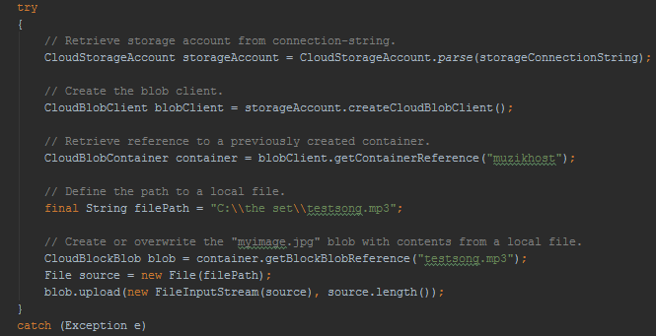

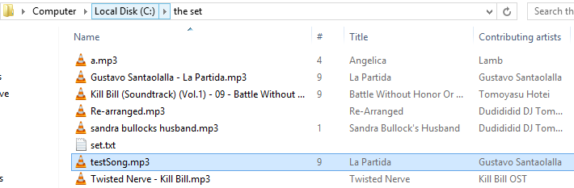

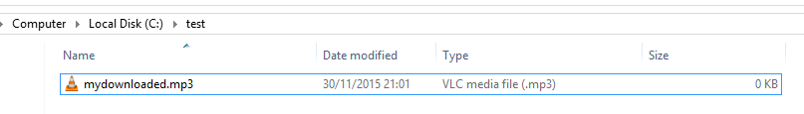

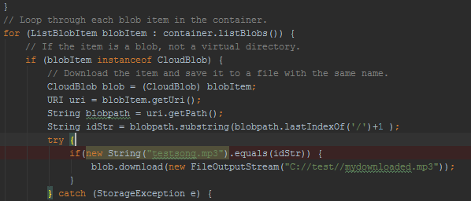

The "mydownloaded.mp3" is empty before I run this code to download it from my container blob on the Azure cloud. The for loop iterates through the various blobs on the cloud until it finds the one I'm looking for. Then it downloads it to "mydownloaded.mp3".

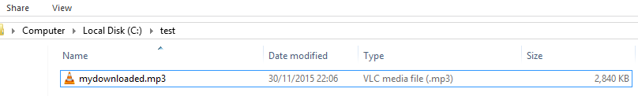

**Board at the start of the week:**

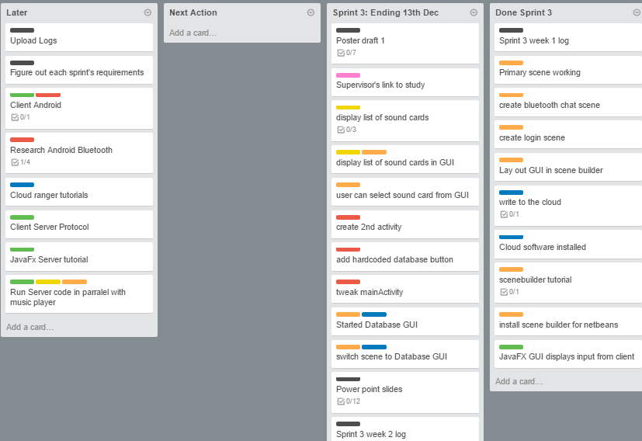

**Board at the end of the week:**

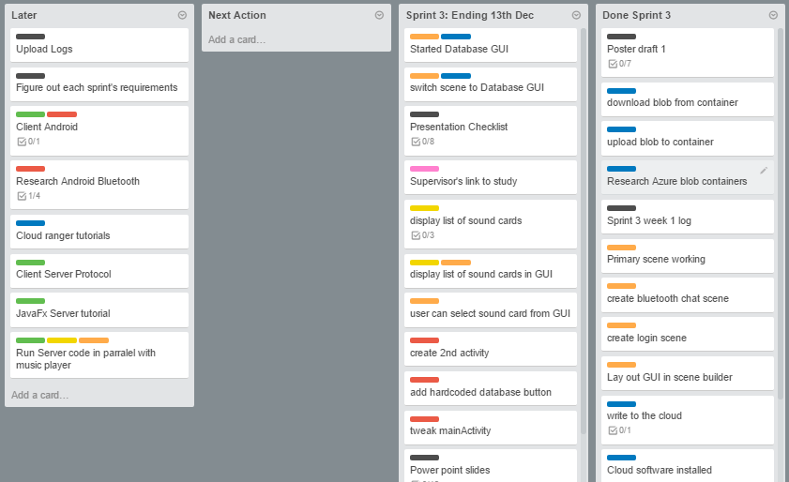

**Weekly time Log bar chart:**

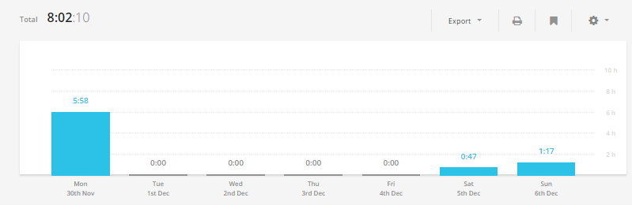

**Weekly Time Log:**

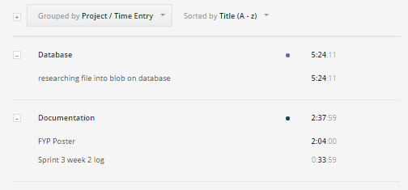

**Weekly log Pie Charts:**

